
SRM Institute of Science and Technology
Mode of Exam
OFFLINE
SET A

College of Engineering and Technology
DEPARTMENT OF ECE
SRM Nagar, Kattankulathur – 603203, Chengalpattu District, Tamilnadu
Academic Year: 2021-2022 (EVEN)
Batch 1
Test: CLAT-3 Date: 27/06/22
Course Code & Title: 18ECC202J / Linear Integrated Circuits Duration: 2 Periods
Year & Sem: II year / IV Sem Max. Marks: 50
Course Articulation Matrix:
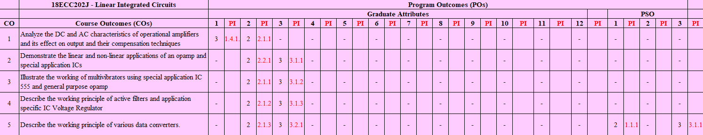

Part - A
(10 x 1 = 10 Marks)
Instructions: Answer ALL
Q. No | Question | Marks | BL | CO | PO | PI
1 | d. Filter | 1 | 1 | 4 | 2 | 2.1.2
2 | b. Q > 10 | 1 | 1 | 4 | 2 | 2.1.2
3 | d. HPF and LPF | 1 | 1 | 4 | 2 | 2.1.2
4 | a. |Vin| ≥ |Vo|+2v | 1 | 2 | 4 | 2 | 2.1.2
5 | d. 90 | 1 | 1 | 4 | 2 | 2.1.2
6 | b. Successive approximation | 1 | 1 | 5 | 2 | 2.1.3
7 | b. 666.67mV | 1 | 2 | 5 | 3 | 3.2.1
8 | a. Flash | 1 | 1 | 5 | 2 | 2.1.3
9 | c. an increase in digital input | 1 | 1 | 5 | 2 | 2.1.3
10 | a. 3.78 V | 1 | 2 | 5 | 3 | 3.2.1
Part – B
( 4 x 10 = 40 Marks)

SECTION B1
Instructions: Answer ANY 2 Questions
11 | 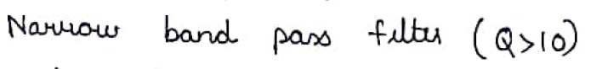  1M  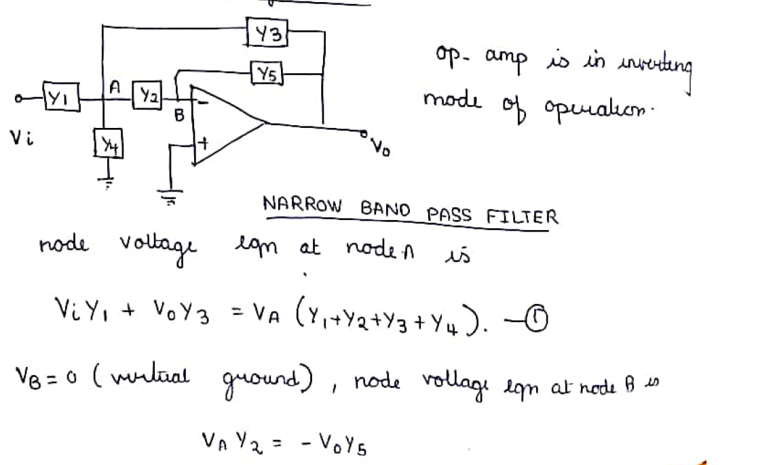  4M  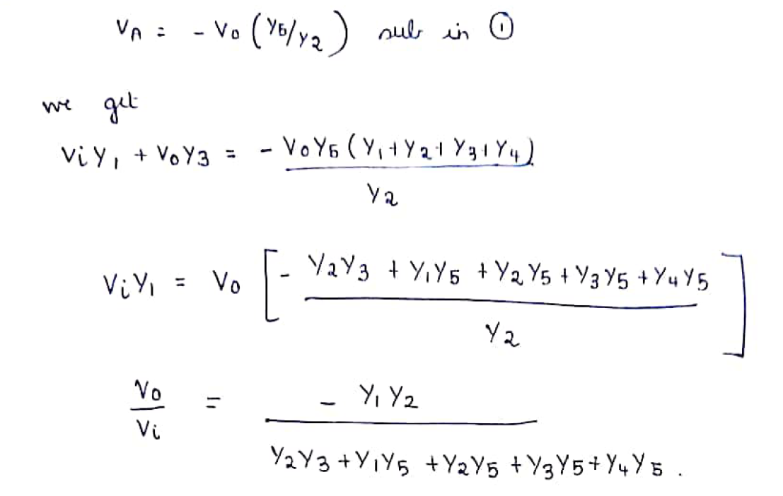  3M  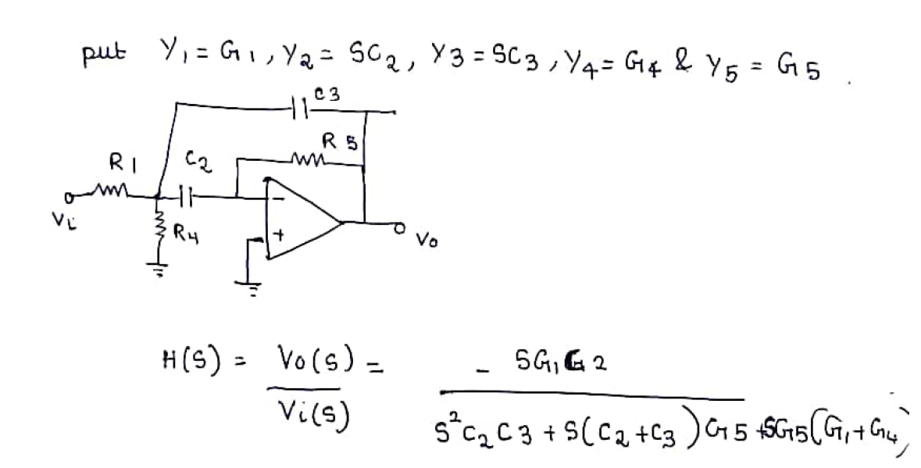  2M | 10 | 3 | 4 | 3 | 3.2.1
12 | 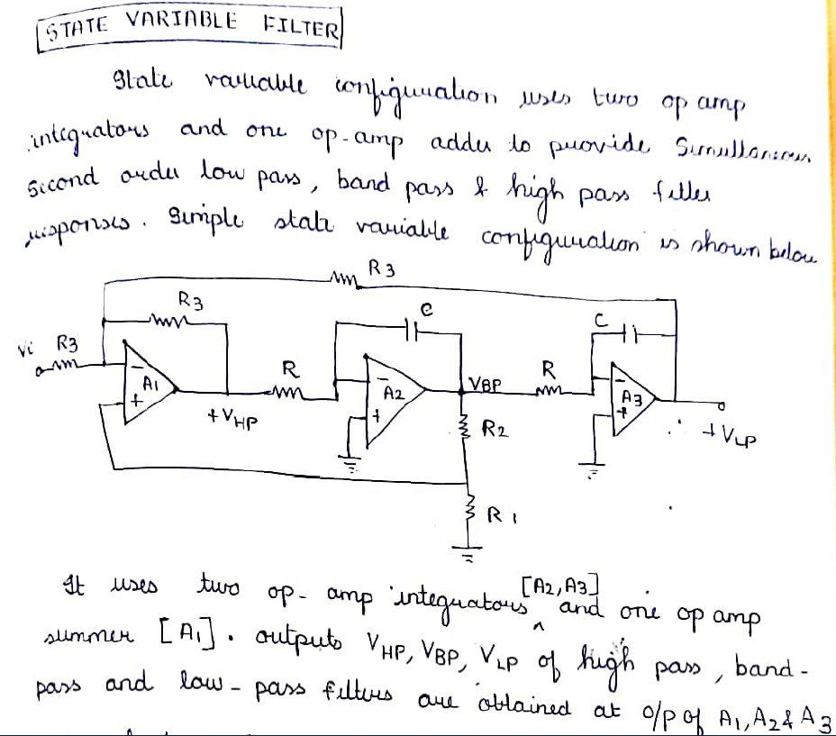  4M  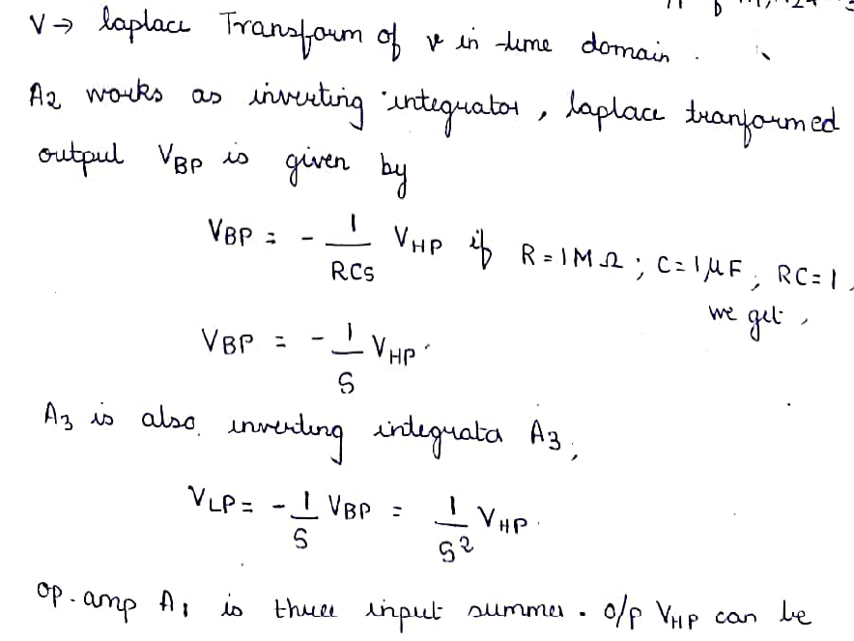  2M  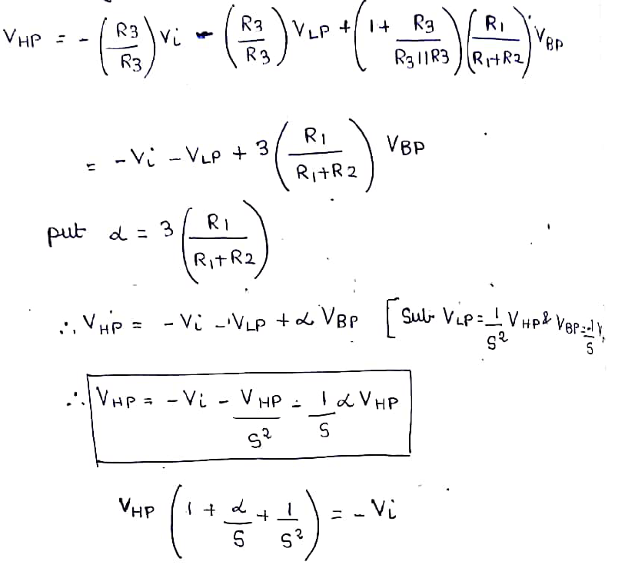  2M  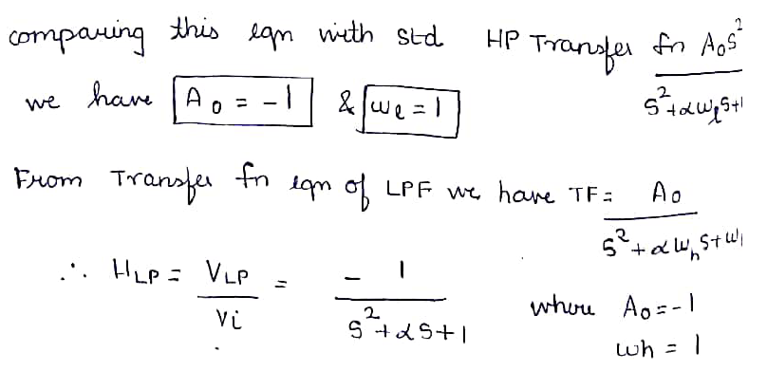  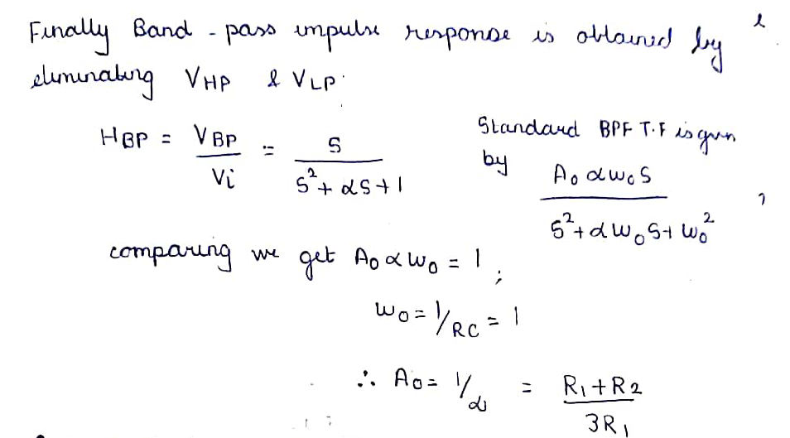  2M | 10 | 3 | 4 | 2 | 2.1.2
13 | 3M  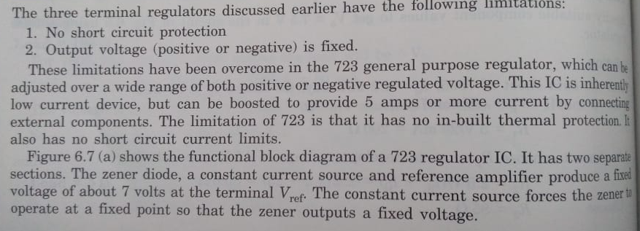  3M  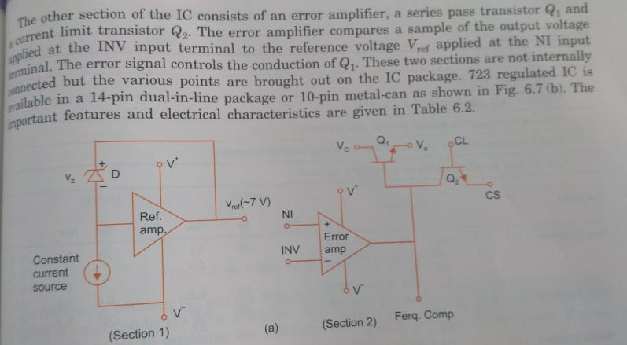  3M  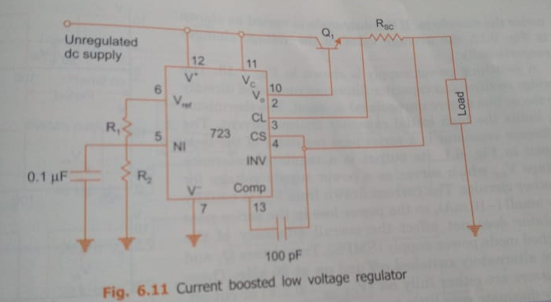  4M | 10 | 2 | 4 | 2 | 2.1.2

SECTION B2
Instructions: Answer ANY 2 Questions
14 | With a neat sketch, explain the operation of weighted resistor DAC  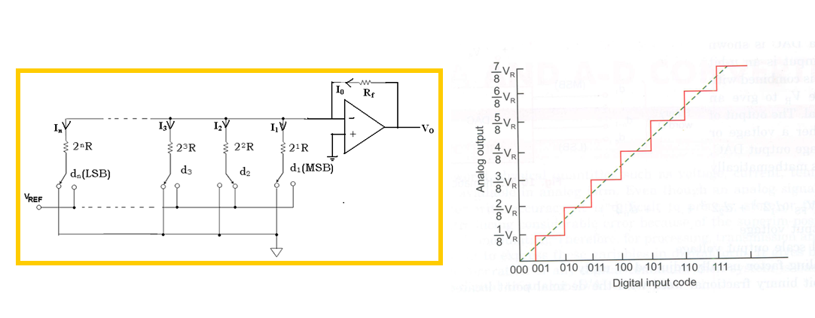  3M  2M  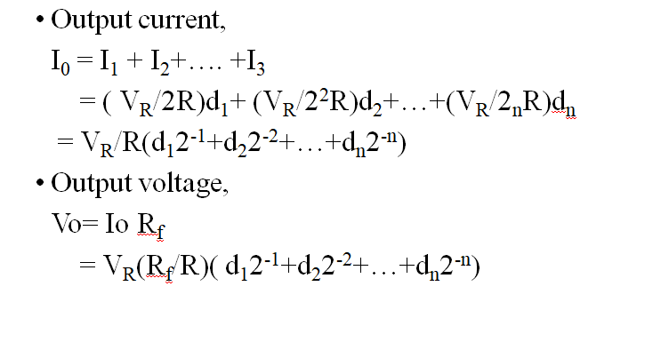  4M  1M  Drawbacks - | 10 | 3 | 5 | 2 | 2.1.3
15 | 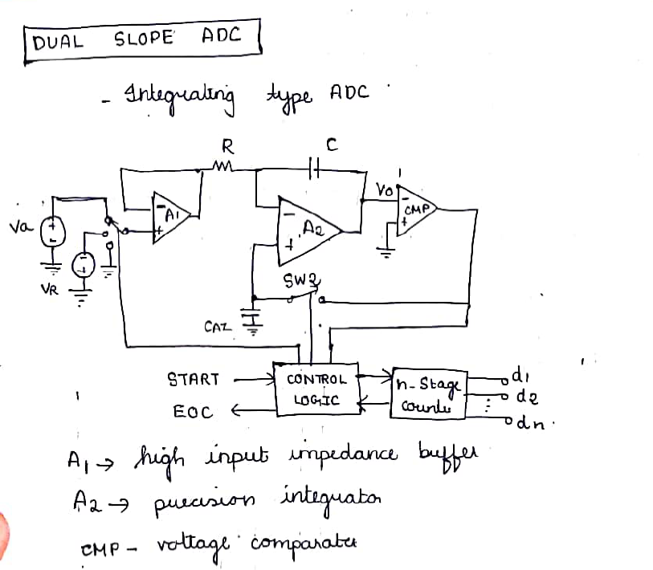  3M  2M  Operation -  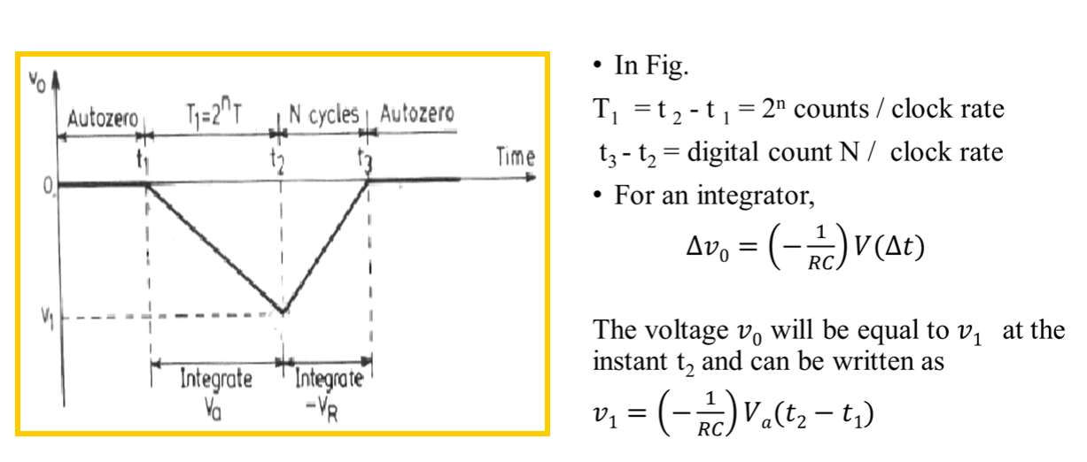  2M  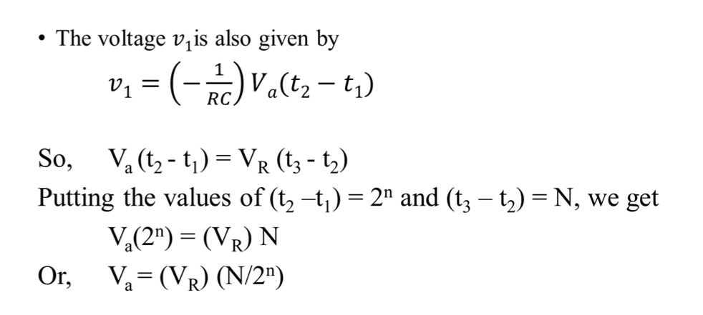  3M | 10 | 2 | 5 | 2 | 2.1.3
16a | 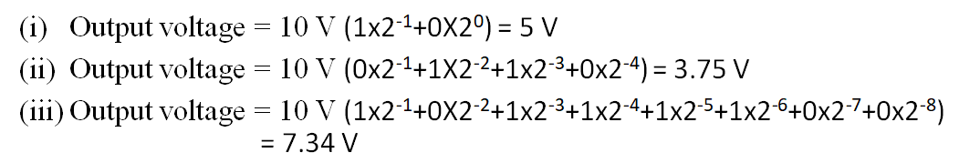  6M | 6 | 4 | 5 | 3 | 3.1.2
16b | 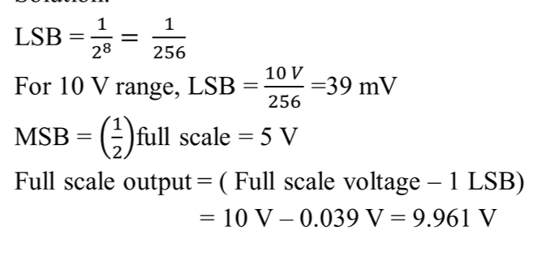  4M | 4 | 4 | 5 | 3 | 3.1.2

